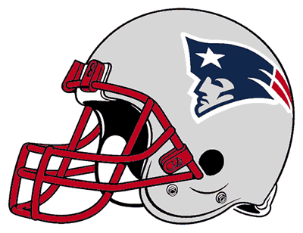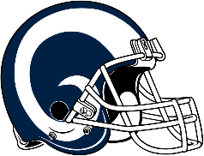**ARE YOU READY FOR SOME FOOTBALL**

SUPERBOWL SPECIALS

**ONLY AVAILABLE**

on SUNDAY, FEB., 3th



**X-LARGE PIZZA with 2 Fresh Toppings**

**ONLY $20.99**

**Plus tax**



2 LARGE PIZZAS with 2 FRESH TOPPINGS EACH

ORDER OF WINGS

ORDER OF GARLIC BREAD STICKS

ORDER OF CHEESY BREAD

2 2-LITER SODA

**ONLY $51.99**

**PLUS TAX**